Android BT HAL 库移植
- Driver
make menuconfig ;选中Enable bluedroid：
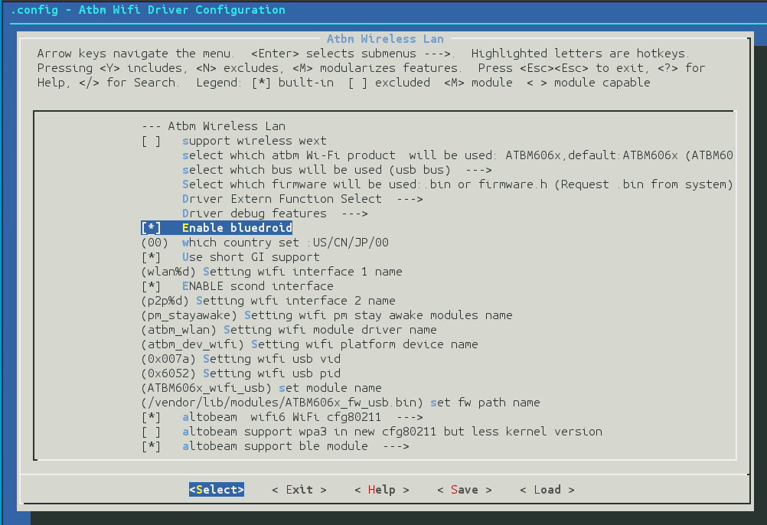
- Hal
将altobeam包拷贝至hardware目录下。
- hardware\altobeam\libbt\atbm.mk文件将复制fw.bin到指定目录，该目录要与kernel配置一致,默认/vendor/etc/firmwar。fw.bin 位置：hardware\altobeam\libbt\conf\firmware。
CUR_PATH := hardware/altobeam/libbt
PRODUCT_COPY_FILES += \
$(CUR_PATH)/conf/firmware/fw.bin:$(TARGET_COPY_OUT_VENDOR)/etc/firmware/fw.bin

- device/rockchip/xxxxx/wifi_bt.mk添加：
diff --git a/device/rockchip/rk3399/wifi_bt.mk b/device/rockchip/rk3399/wifi_bt.mk
index 6d53792560..559f0e6811 100644
--- a/device/rockchip/rk3399/wifi_bt.mk
+++ b/device/rockchip/rk3399/wifi_bt.mk
@@ -39,5 +39,8 @@
# rda587x, #like rtl8188+rda587x
# mt6622, #like rtl8188+mt6622
#
-BOARD_CONNECTIVITY_VENDOR := Broadcom
-BOARD_CONNECTIVITY_MODULE := ap6xxx
+#BOARD_CONNECTIVITY_VENDOR := Broadcom
+#BOARD_CONNECTIVITY_MODULE := ap6xxx
+
+BOARD_CONNECTIVITY_VENDOR := AltoBeam
+BOARD_CONNECTIVITY_MODULE := atbm606x

- device/rockchip/common/wifi_bt_commod.mk添加：
diff --git a/device/rockchip/common/wifi_bt_common.mk b/device/rockchip/common/wifi_bt_common.mk
index 9e157683b6..c6d5d2a2b7 100644
--- a/device/rockchip/common/wifi_bt_common.mk
+++ b/device/rockchip/common/wifi_bt_common.mk
@@ -37,5 +37,15 @@ BLUETOOTH_ENABLE_FM := false
endif
endif

+
+ifeq ($(strip $(BOARD_CONNECTIVITY_VENDOR)), Altobeam)
+BOARD_HAVE_BLUETOOTH := true
+BOARD_HAVE_BLUETOOTH_ATBM := true
+
+ifeq ($(strip $(BOARD_CONNECTIVITY_MODULE)), atbm606x)
+BLUETOOTH_USE_BPLUS := true
+BLUETOOTH_ENABLE_FM := false
+endif
+endif

- device/rockchip/common/device.mk 添加：
diff --git a/device/rockchip/common/device.mk b/device/rockchip/common/device.mk
index 47fe75c4b2..94c3f62cd5 100644
--- a/device/rockchip/common/device.mk
+++ b/device/rockchip/common/device.mk
@@ -794,6 +794,10 @@ ifeq ($(strip $(BOARD_HAVE_BLUETOOTH_RTK)), true)
include hardware/realtek/rtkbt/rtkbt.mk
endif

+ifeq ($(strip $(BOARD_HAVE_BLUETOOTH_ATBM)), true)
+include hardware/altobeam/libbt/atbm.mk
+endif
+
ifeq ($(strip $(TARGET_BOARD_PLATFORM_PRODUCT)), box)
include device/rockchip/common/samba/rk31_samba.mk
PRODUCT_COPY_FILES += \

- 修改Android/system/core/rootdir/init.rc ，修改/dev/atbm_ioctl权限，添加：
diff --git a/system/core/rootdir/init.rc b/system/core/rootdir/init.rc
index 0fa9febdd3..20f382beab 100644
--- a/system/core/rootdir/init.rc
+++ b/system/core/rootdir/init.rc
@@ -820,6 +820,8 @@ on property:security.perf_harden=0
on property:security.perf_harden=1
write /proc/sys/kernel/perf_event_paranoid 3

+ chmod 777 /dev/atbm_ioctl
# on shutdown
# In device's init.rc, this trigger can be used to do device-specific actions
# before shutdown. e.g disable watchdog and mask error handling

- system修改,配置可发现与可连接模式。
diff --git a/system/bt/btif/src/btif_core.cc b/system/bt/btif/src/btif_core.cc
index aa77979acf..036104c2d3 100644
--- a/system/bt/btif/src/btif_core.cc
+++ b/system/bt/btif/src/btif_core.cc
@@ -929,7 +929,9 @@ bt_status_t btif_set_adapter_property(const bt_property_t* property) {

case BT_SCAN_MODE_CONNECTABLE_DISCOVERABLE:
disc_mode = BTA_DM_GENERAL_DISC;
+ disc_mode |= BTA_DM_BLE_GENERAL_DISCOVERABLE;
conn_mode = BTA_DM_CONN;
+ conn_mode |= BTA_DM_BLE_CONNECTABLE;
break;

default:

- Libbt-vendor.so库加载日志，用logcat指令查看，设备打开成功：
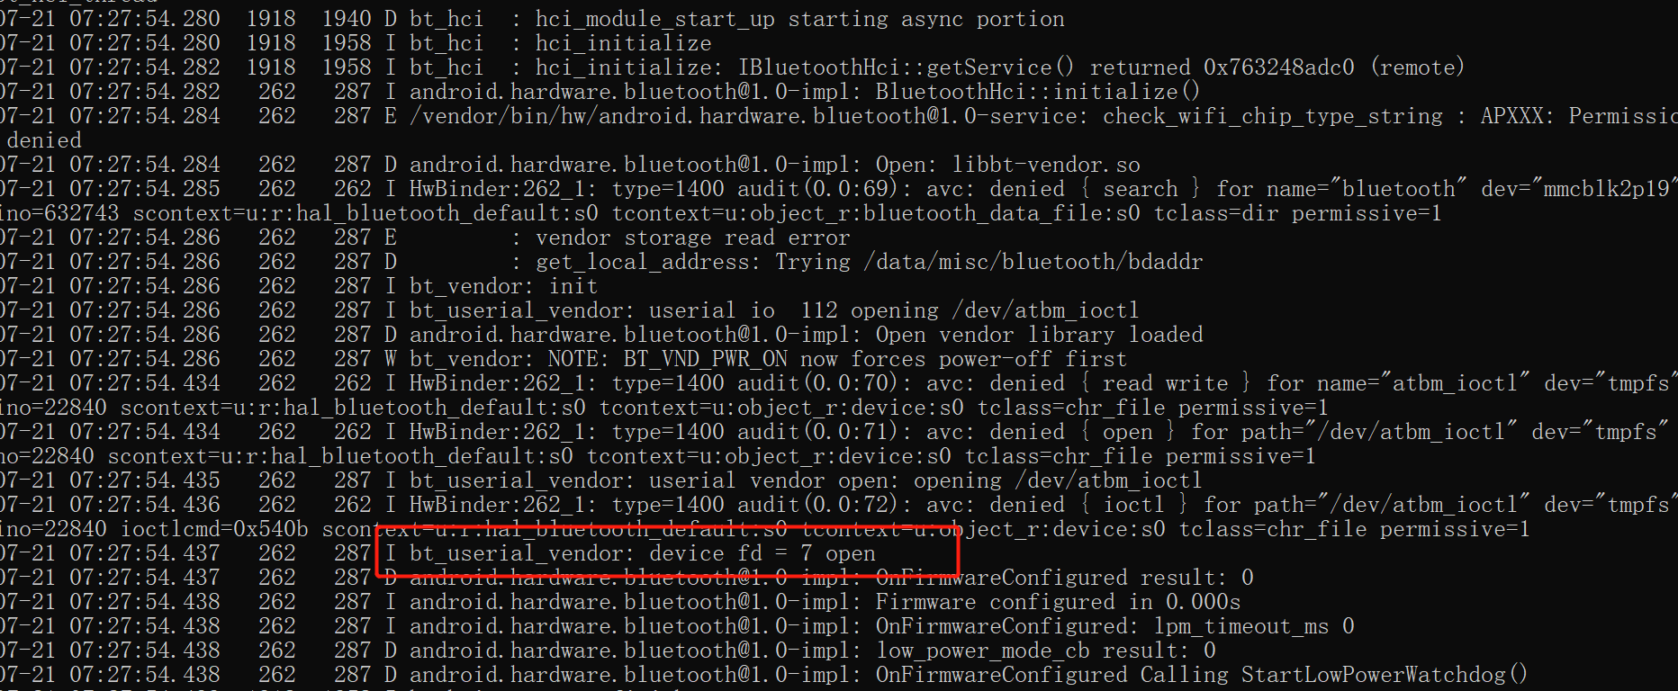

- 驱动修改
驱动部分只修改了字符设备驱动atbm_ioctl_fops ，将发到我们协议栈的数据通过文件节点/dev/atbm_ioctl传给bluedroid.
流程：
- 在打开文件节点/dev/atbm_ioctl时，配置ble()共存。
- read阻塞。读到数据先放到rx_skb_queue 队列中，再通过bt_read_wait唤醒read读取队 列里面的数据。
- 通过atbm_ioctl_write发送hci数据.

文件节点的名称修改:
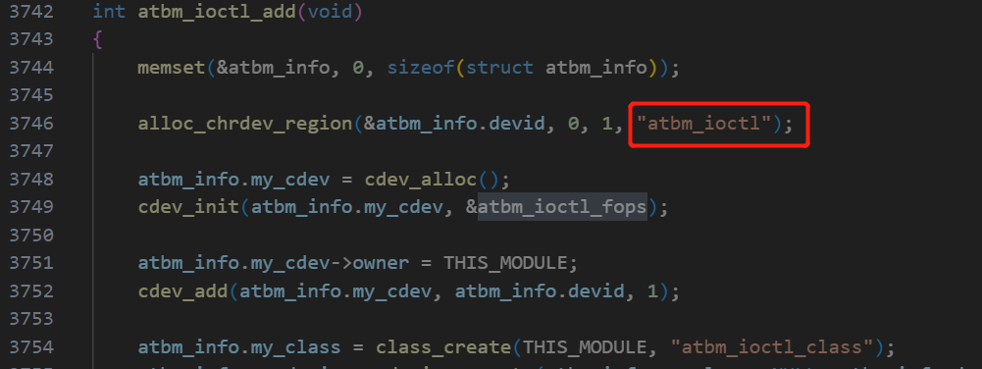

- libbt-vendor.so通过文件描述符读写hci数据的接口：
Android\hardware\interfaces\bluetooth\1.0\default\h4_protocol.cc
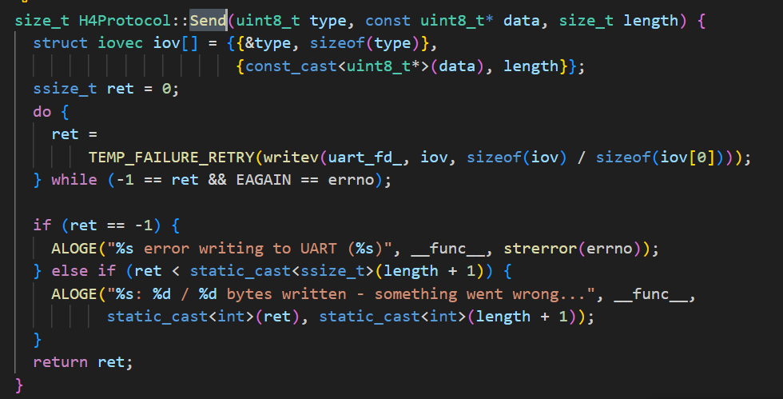

Android\hardware\interfaces\bluetooth\1.0\default\hci_packetizer.cc
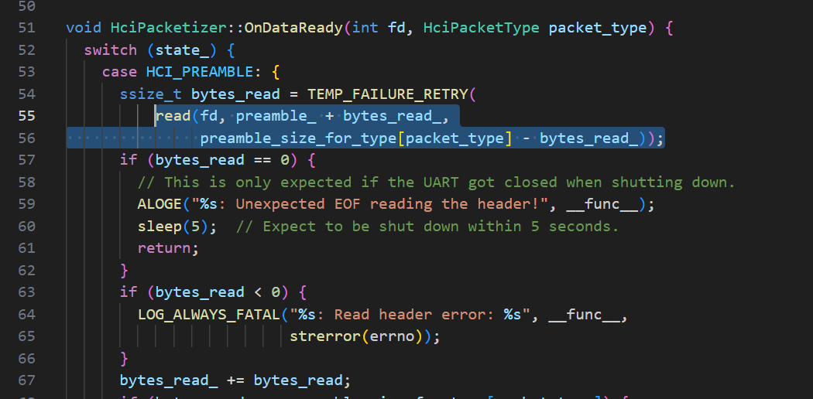
- 自测：
测试设备无显示屏情况下，准备工具：
- 调试工具adb.exe
- 安卓投屏工具Scrcpy.exe
- BLE调试工具nRF.Connect.apk

- 手机端安装并打开nRF.Connect.apk 创建一个广播设备
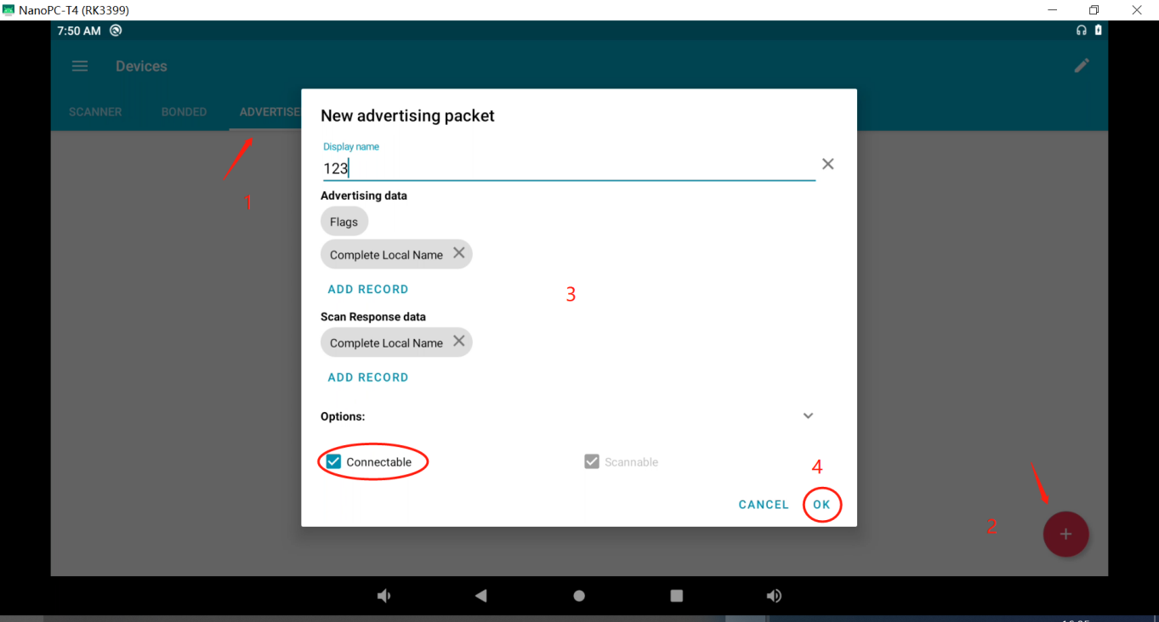

- 设备端：usb连接设备端的otg口
Win+r 输入cmd 打开命令运行窗口，安装nRF.Connect.apk：
C:\>adb root & adb remount
adbd is already running as root
remount succeeded

C:\>adb install C:\doc\tool\nRF.Connect.4.24.3.apk
Performing Streamed Install
Success

- 运行Scrcpy.exe投屏，打开nRF.Connect工具，扫描手机设备，连接。
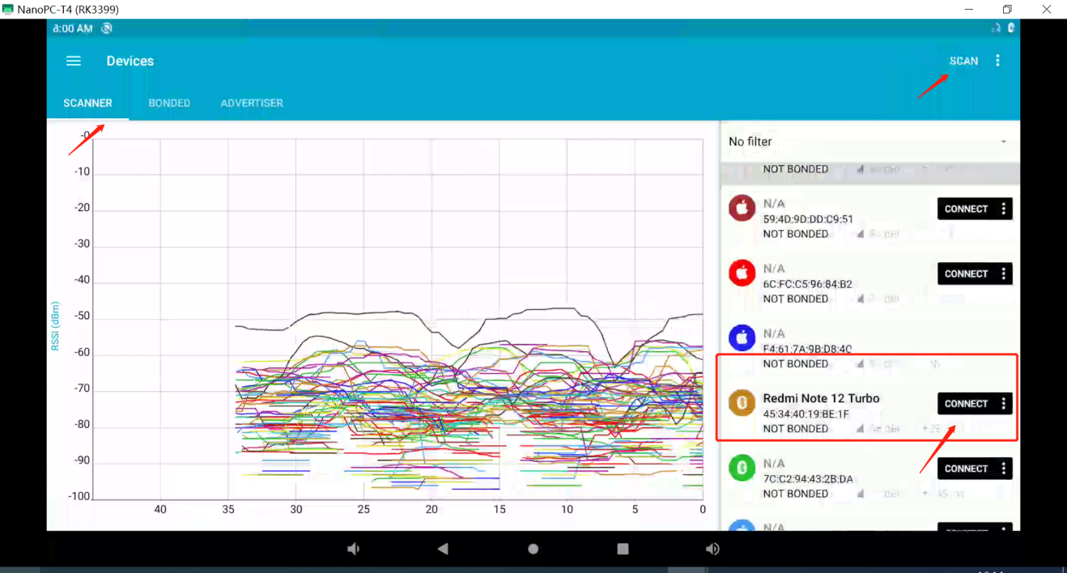
- 连接成功后，获取属性值,测试成功：
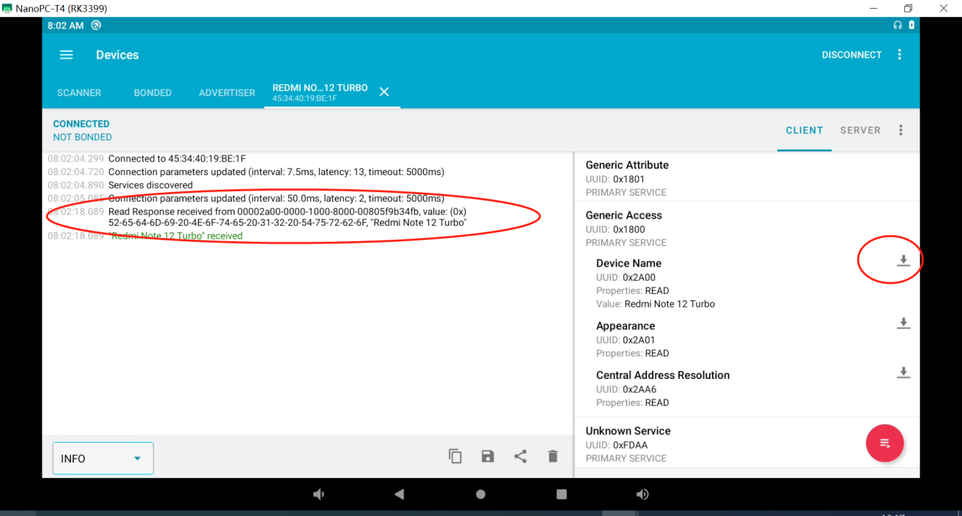

- 日志导出
查看Android系统日志：logcat
查看Kernel日志：dmesg 或 cat /dev/kmsg

